A taxi charges $1 to begin with, and $3 for each mile traveled. y is the amount charged for traveling x miles.

x
1
2
3
4
5
6
7
8
9
10
y
4
7
10
13
16
19
22
25
28
31

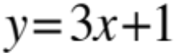

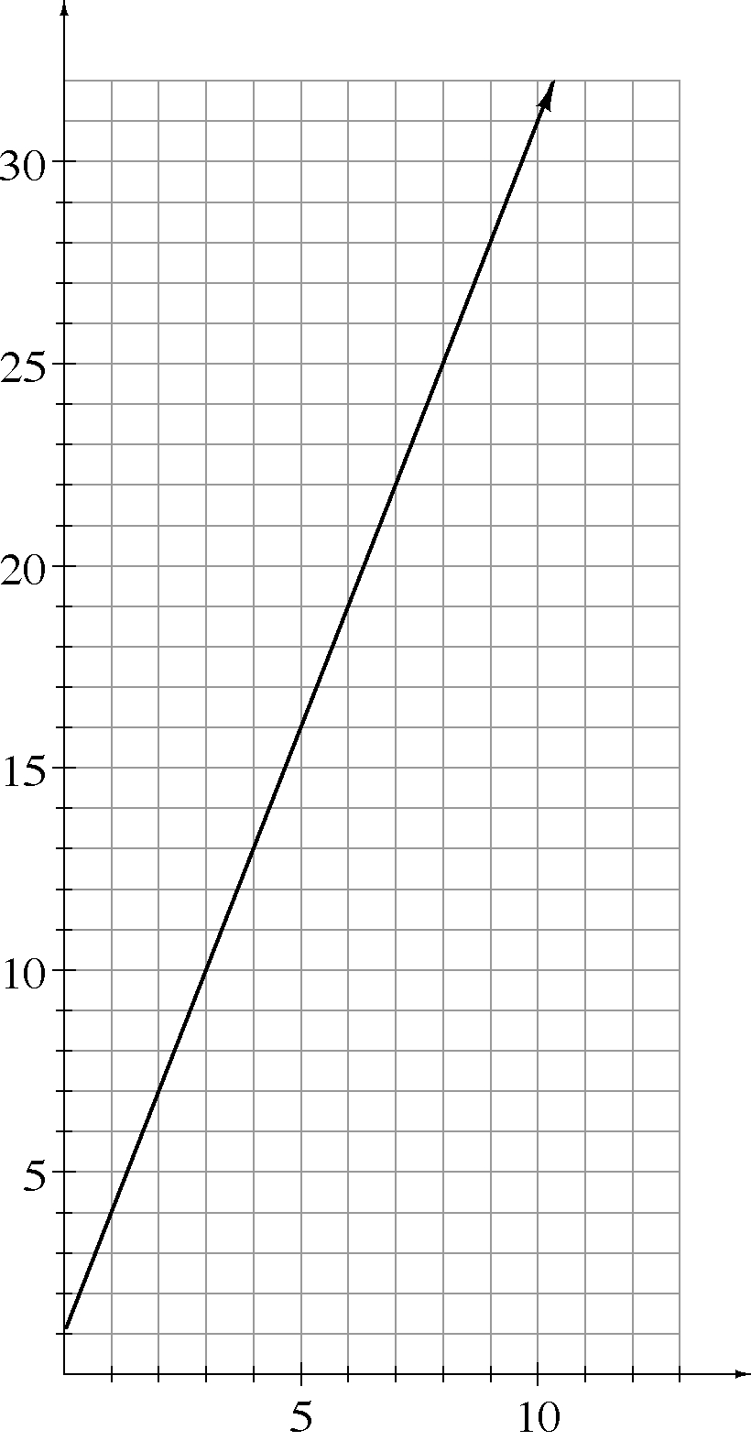
y
x

Diane owed $4 at the start of the month. She managed to save $5 each week. y is the amount of money she had after x weeks.

x
0
1
2
3
4
5
6
7
8
9
10
y
–4.00
1.00
6.00
11.00
16.00
21.00
26.00
31.00
36.00
41.00
46.00

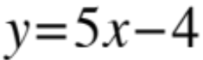

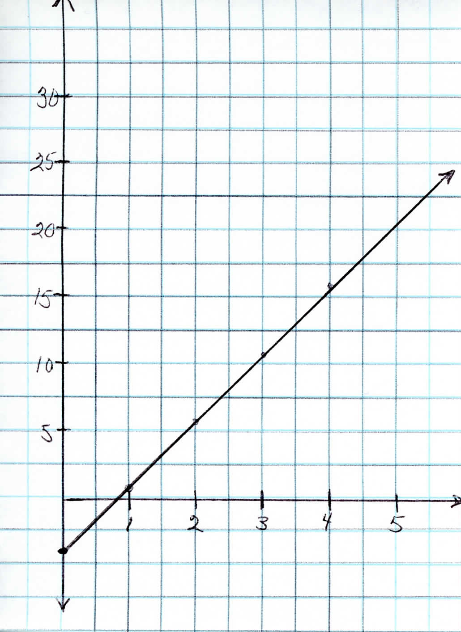

Carl bought 5 pounds of coffee and drank 0.25 pounds each day. y is the amount of coffee he had after x days.

x
0
1
2
3
4
5
6
7
8
9
10
y
5.00
4.75
4.50
4.25
4.00
3.75
3.50
3.25
3.00
2.75
2.50

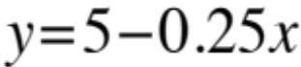

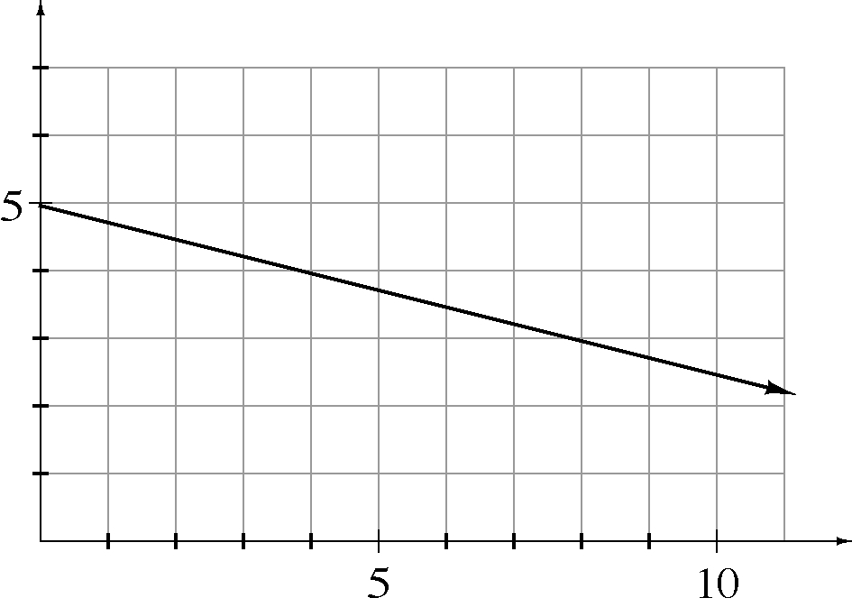
y
x

Lisa was running a 26-mile marathon and she paced herself so she ran about 8 miles an hour. y is the number of miles she had left to run after x hours.

x
0.00
0.25
0.50
0.75
1.00
1.25
1.50
1.75
2.00
2.25
2.50
2.75
3.00
3.25
y
26
24
22
20
18
16
14
12
10
8
6
4
2
0

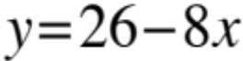

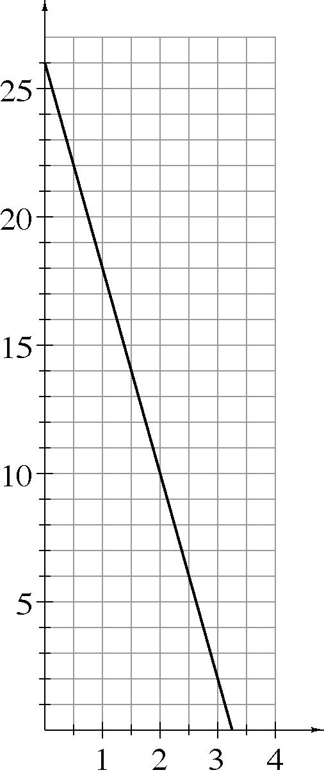
y
x

Arlan had $3,000 in his saving account and was saving $50 per week. y is the total amount in his account after x weeks.

x
0
1
2
3
4
5
6
7
8
9
10
y
3000
3050
3100
3150
3200
3250
3300
3350
3400
3450
3500

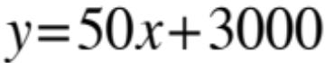

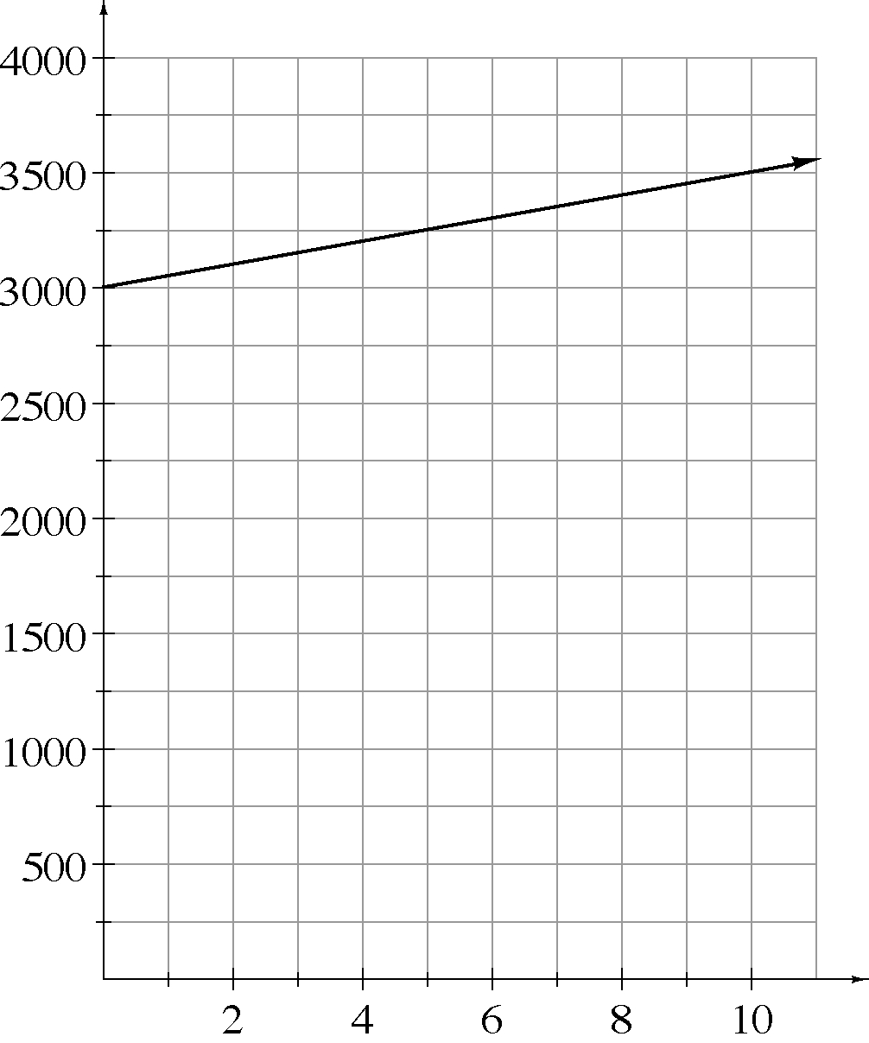
y
x

Sylvia had $12,000 in her saving account and was spending at a rate of $200 each week. y is the amount in her account after x weeks.

x
0
1
2
3
4
5
6
7
8
9
10
y
12000
11800
11600
11400
11200
11000
10800
10600
10400
10200
10000

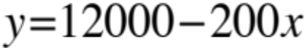

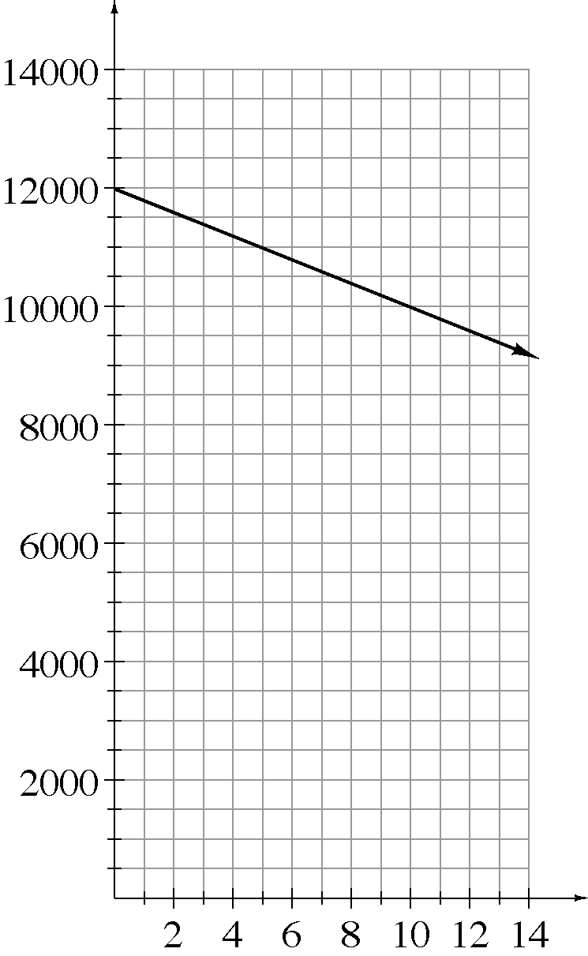
y
x

Roger left his apartment walking at a rate of about 1.5 miles per hour. y is his distance from the apartment after x hours.

x
0.00
0.25
0.50
0.75
1.00
1.25
1.50
1.75
2.00
2.25
2.50
2.75
3.00
y
0.00
0.38
0.75
1.13
1.50
1.88
2.25
2.63
3.00
3.38
3.75
4.13
4.50

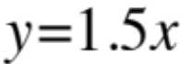

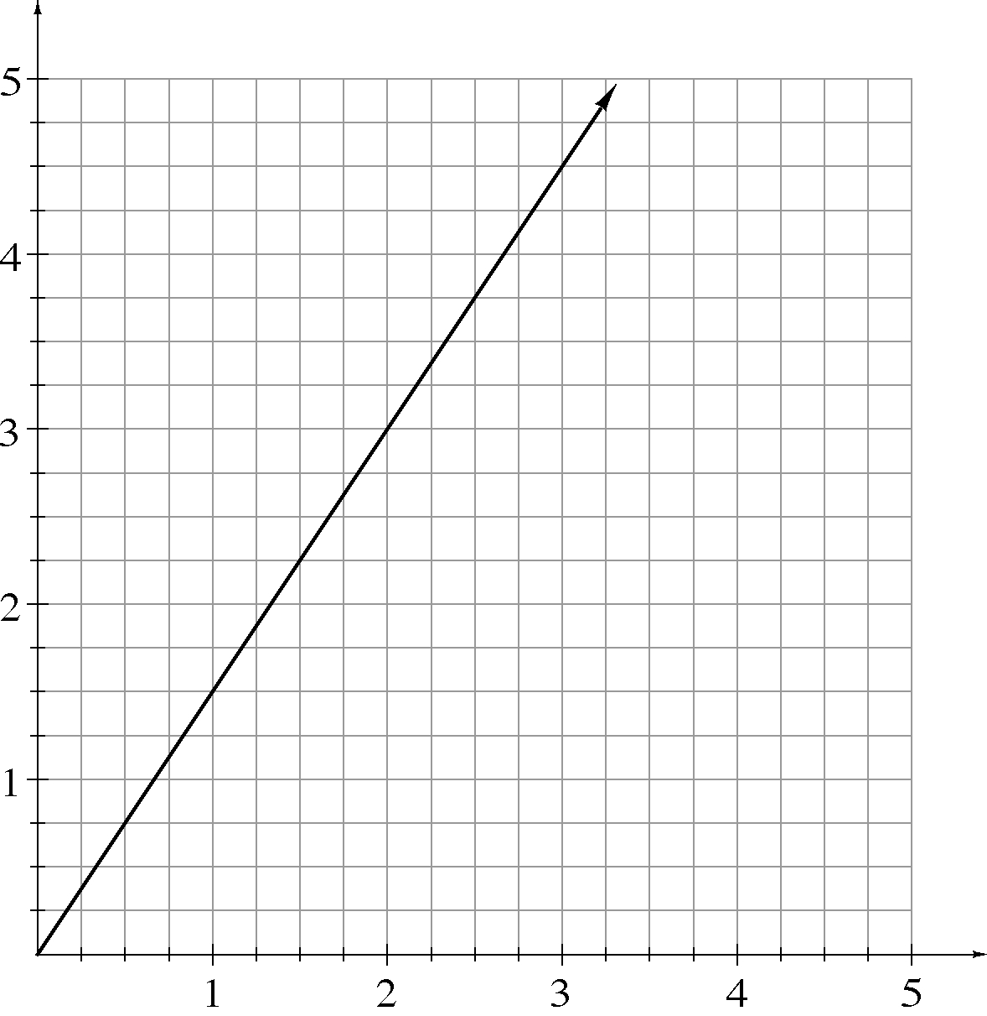
y
x

Alonzo needs two-thirds of a cup of chopped walnuts for each batch of brownies he makes.
y = the total number of cups of nuts needed for x batches of brownies.

x
1
2
3
4
5
6
7
8
9
10
y
0.67
1.33
2.00
2.67
3.33
4.00
4.67
5.33
6.00
6.67

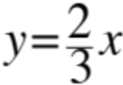

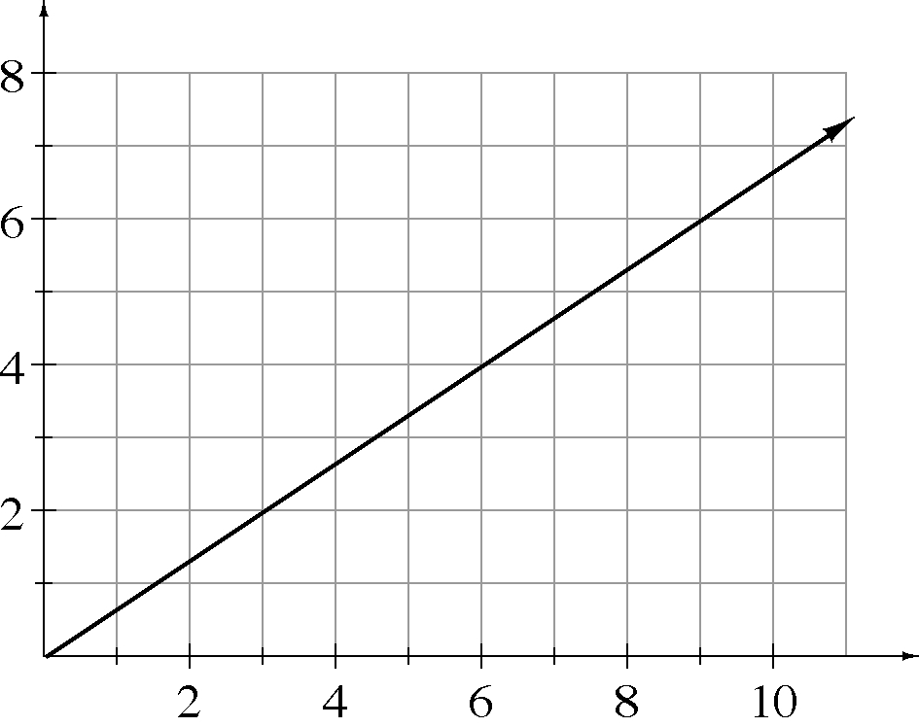
y
x

Alex only uses his car to commute to work. He starts with a full tank of 14 gallons, and uses about 0.4 gallons of gas to drive back and forth from work each day. y is the number of gallons left in the tank after x days.

x
0
1
2
3
4
5
6
7
8
9
10
y
14
13.6
13.2
12.8
12.4
12
11.6
11.2
10.8
10.4
10

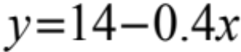

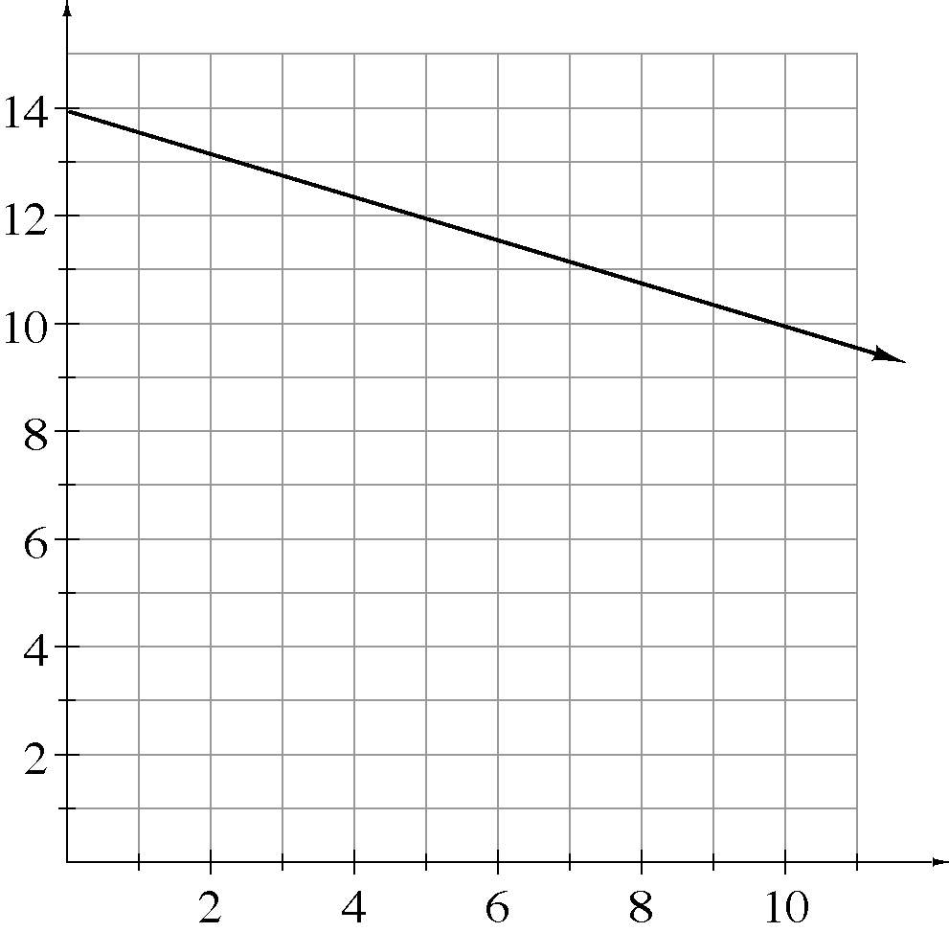
y
x

Kyle bought $10 worth of chips to play roulette and is losing an average rate of $0.75 per spin on the wheel. y is the amount he has left after x spins of the roulette wheel.

x
1
2
3
4
5
6
7
8
9
10
y
9.25
8.50
7.75
7.00
6.25
5.50
4.75
4.00
3.25
2.50

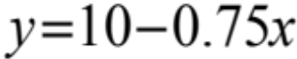

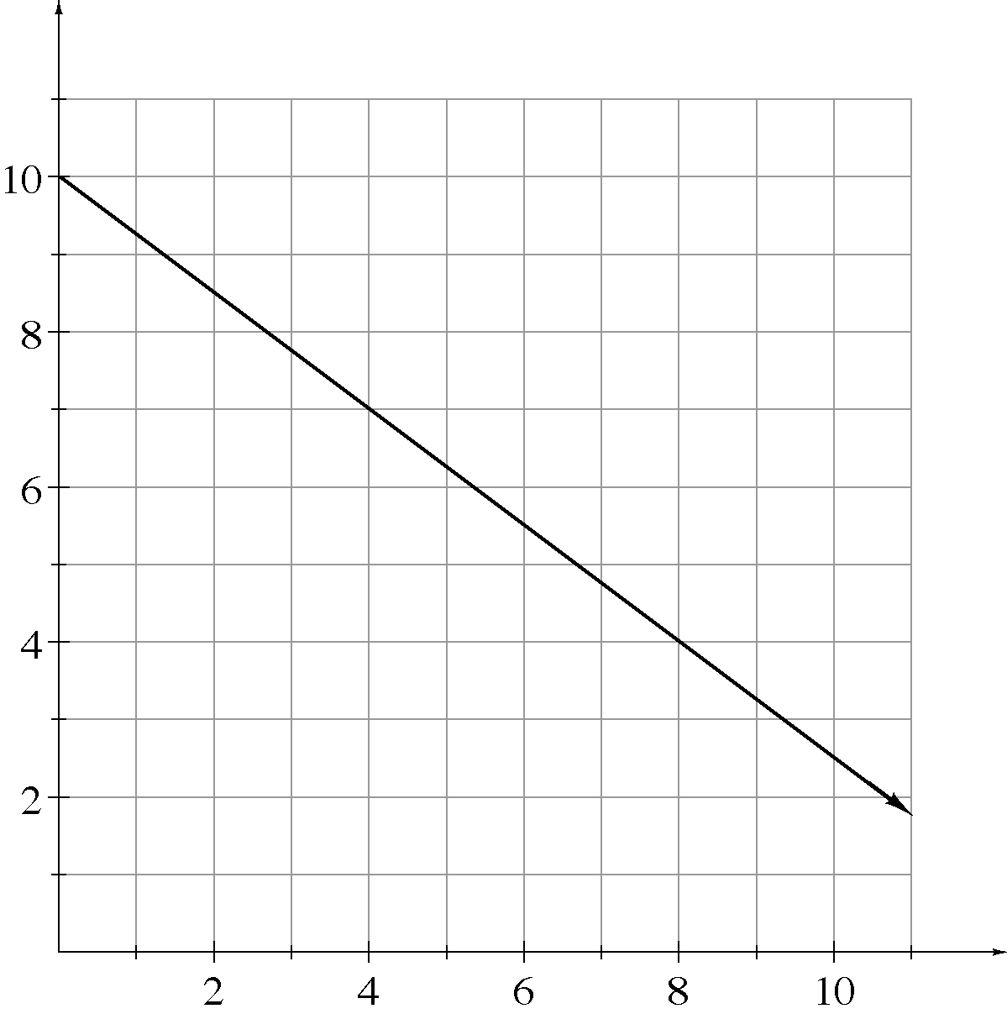
y
x

